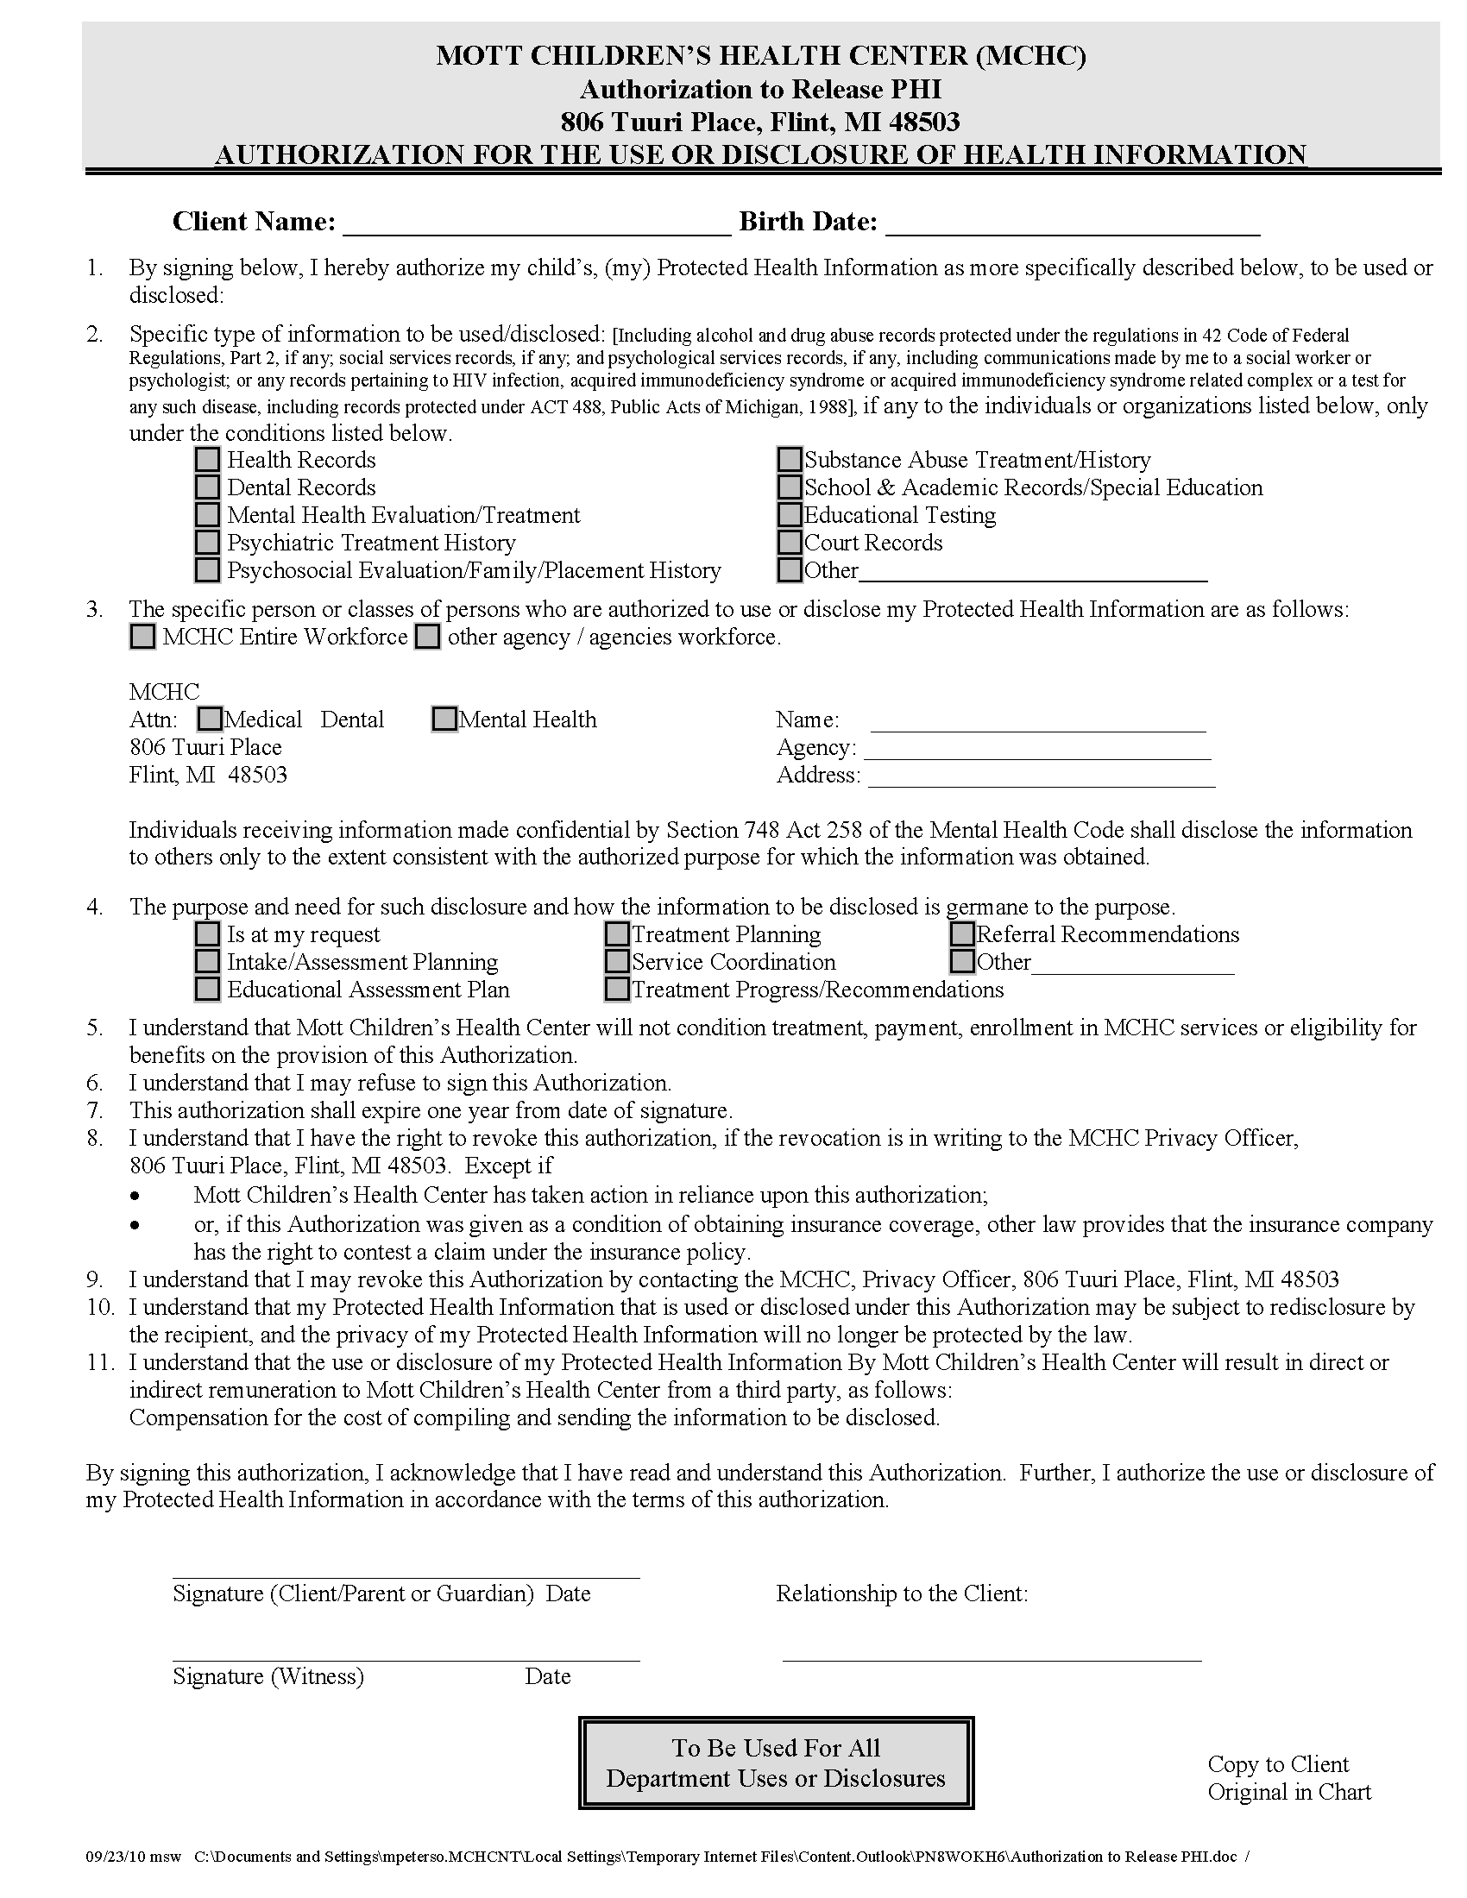
Batman
01/01/1979
FROM 01/01/1979 TO PRESENT: Any and all MEDICAL RECORDS, including but not limited to patient history form(s), reports, etc. pertaining to Batman SSN: xxx-xx-5555, DOB: 01/01/1979.
X
RECORDS
Axiom Requisition Copy Service
2869 Jolly Road Okemos, MI 48864
X
Litigation
Order No: 01-29018-002

